Project Design Phase-II
Technology Stack (Architecture & Stack)

Date | 28 September 2026
Team ID | 6ab2210011b716a3e52c62c6
Project Name | Streamlining IT Procurement: Automating Standard Laptop Orders with Flow Designer
Maximum Marks | 4 Marks

Technical Architecture:

The technical architecture of the project is designed using the ServiceNow Cloud Platform to automate the standard laptop procurement process. The user submits a laptop request through the ServiceNow Service Catalog. A Flow Designer workflow is triggered when the request is submitted.

The Flow Designer processes the request and uses the Create Catalog Task action to automatically create a procurement task. The Requested Item Record is used to pass the request information to the task. The request and task information are stored within the ServiceNow platform.

The complete application is hosted on the ServiceNow Cloud Platform, which provides the application environment and data storage. The workflow reduces manual processing and provides a standardized way to handle laptop orders.

Architecture Flow:

IT User → ServiceNow Service Catalog → Flow Designer → Create Catalog Task → Requested Item Record → ServiceNow Cloud Platform → IT Procurement Team
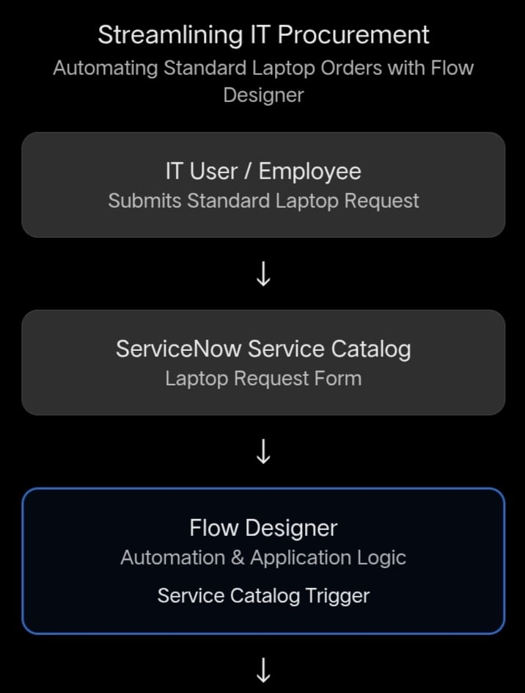
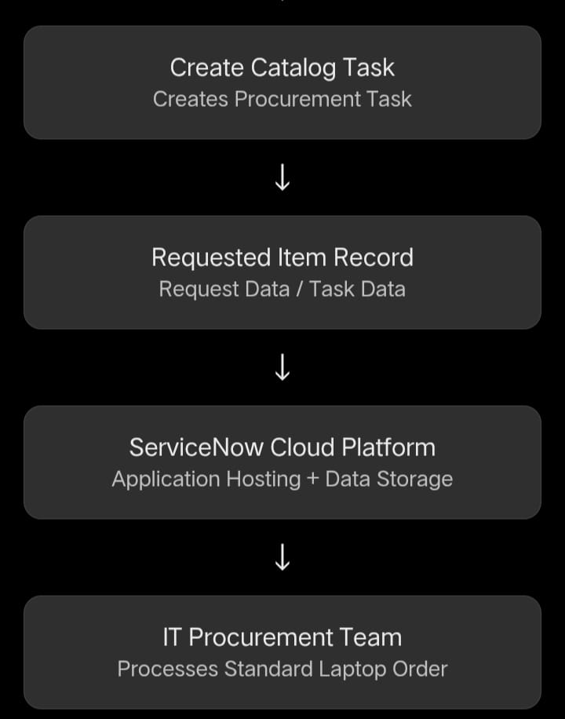

Table-1 : Components & Technologies:

S.No | Component | Description | Technology
1 | User Interface | Users submit standard laptop requests through the Service Catalog | ServiceNow Service Catalog
2 | Application Logic-1 | Captures and processes the laptop request | ServiceNow Flow Designer
3 | Application Logic-2 | Creates a catalog task for IT procurement | Flow Designer – Create Catalog Task
4 | Application Logic-3 | Uses requested item information to process the task | ServiceNow Request Item Record
5 | Database | Stores requests, users, catalog items and task records | ServiceNow Database
6 | Cloud Database | Cloud-based data storage used by ServiceNow | ServiceNow Cloud Platform
7 | File Storage | Stores related documents or attachments if required | ServiceNow Attachments / File Storage
8 | External API-1 | No external API is required for the standard laptop ordering workflow | Not Applicable
9 | External API-2 | No second external API is required | Not Applicable
10 | Machine Learning Model | Machine learning is not required for standard laptop order automation | Not Applicable
11 | Infrastructure (Server / Cloud) | Hosts the application and automation workflow | ServiceNow Cloud Platform

Table-2: Application Characteristics:
S.No | Characteristics | Description | Technology
1 | Open-Source Frameworks | No separate open-source framework is required for this ServiceNow-based project | Not Applicable
2 | Security | User authentication, role-based access and ServiceNow platform security are used | ServiceNow Security / Access Controls
3 | Scalable Architecture | The workflow can handle multiple standard laptop requests through automated Flow Designer processes | ServiceNow Flow Designer
4 | Availability | The application is hosted on the ServiceNow cloud platform and can be accessed through the web | ServiceNow Cloud Platform
5 | Performance | Automation reduces manual processing and creates procurement tasks automatically | Flow Designer

